Task 1
1. Introduction
This report provides a comprehensive analysis of a C++ program designed to simulate a Unix-like shell environment. The program provides a command-line interface that allows users to execute built-in commands, manage environment variables, handle file I/O redirection, and execute external system programs using process management system calls.
2. Detailed Function Analysis
2.1 Save IO:
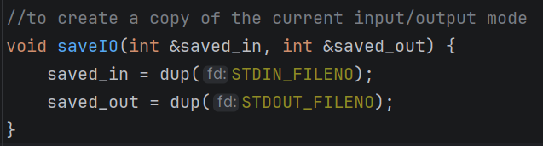
Purpose: This function creates a backup of the current standard input and standard output file descriptors.
Logic:
- It uses the dup() system call, which creates a copy of a file descriptor.
- STDIN_FILENO (0) and STDOUT_FILENO (1) are duplicated and stored in the reference parameters.
Why it's needed: When the shell redirects output to a file, it overrides the terminal's output. This function ensures that the shell can reverse back to normal mode by taking the input from the user and print it normally not in a file.

2.2 Restore IO:
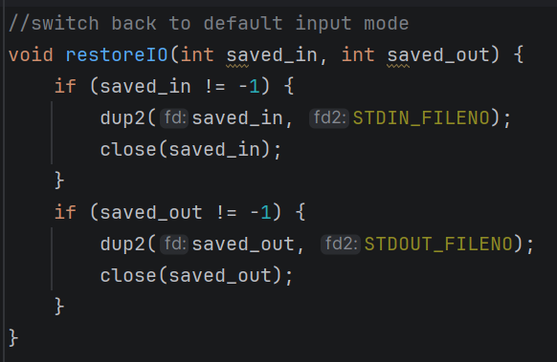
Purpose: This function restores the shell's input and output back to the original state (the terminal).
Logic:
- It uses dup2(), which forces a specific file descriptor to point to the same location as another.
- It redirects saved_in back to STDIN_FILENO and saved_out back to STDOUT_FILENO.
- Finally, it closes the backup descriptors to prevent memory leaks.

2.3 Apply Redirection
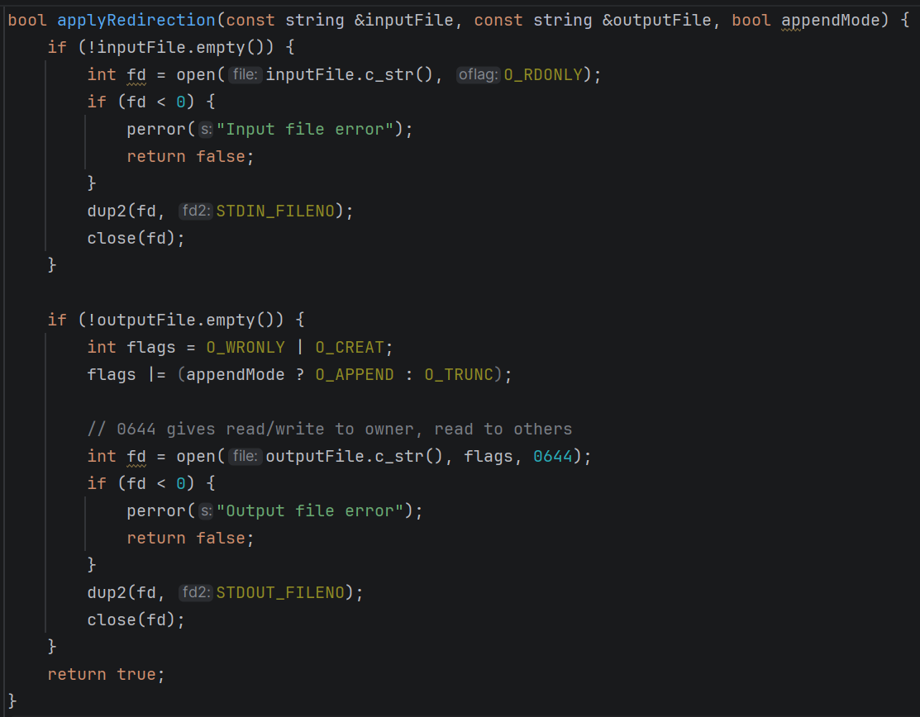
Purpose: This function handles the logic for <, >, and >> operators.
Logic:
- Input Redirection (<): Opens the specified file in read-only mode (O_RDONLY). If successful, it uses dup2 to replace STDIN with the file's descriptor.
- Output Redirection (> and >>): If append Mode is false, it uses O_TRUNC to overwrite the file.
  - If append Mode is true, it uses O_APPEND to add to the end of the file.
  - It uses O_CREAT with permissions 0644 (owner can read/write, others can read) to create the file if it doesn't exist.
- Return: Returns true if redirection was successful, or false (with an error message) if a file could not be opened.

3. The Main Loop and Command Processing
The main function serves as the heart of the shell, operating in a continuous while loop.
3.1 Shell Initialization and Batch Mode
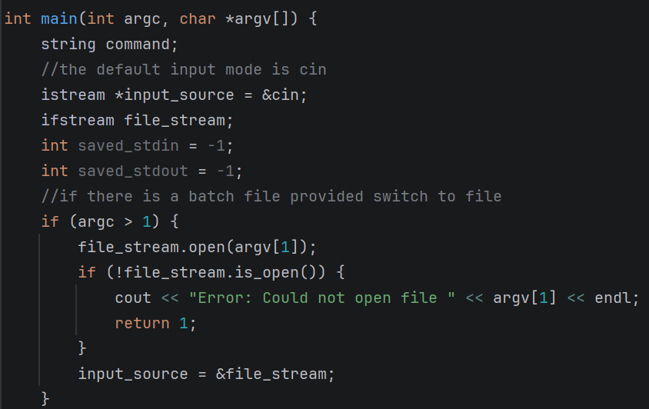
- The shell checks argc. If an argument is provided, it tries to open that file as an ifstream and redirects the input source from cin to the file.
- getcwd(cwd, sizeof(cwd)) is called in every iteration to retrieve the current working directory, which is displayed in the prompt.

3.2 Command Tokenization (Parsing)
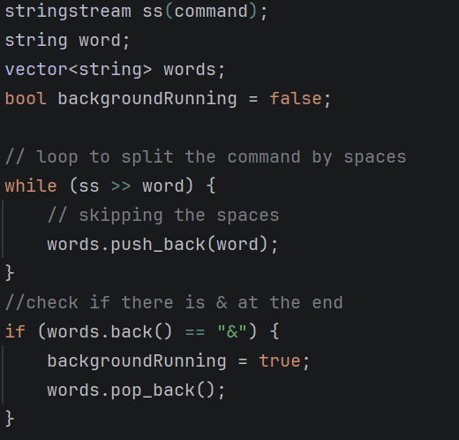
- The shell reads a line using getline().
- It uses stringstream to split the string into a vector of strings named words. This separates the command from its arguments by whitespace.
- It checks for the ampersand symbol at the end of the command. If found, backgroundRunning is set to true, and the ampersand is removed from the arguments.

3.3 Redirection Parsing
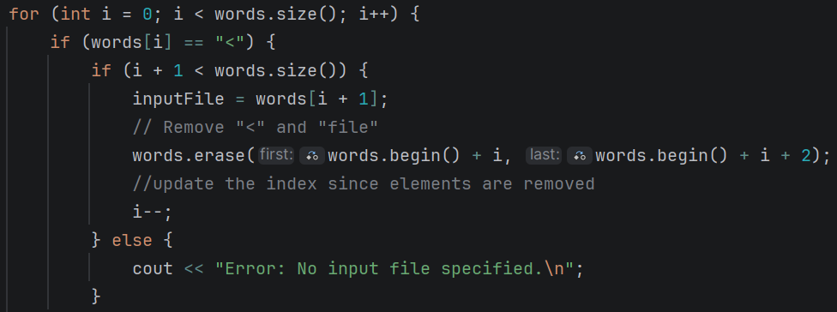

The shell iterates through the tokens to find redirection symbols:
- <: Identifies the next token as the input source.
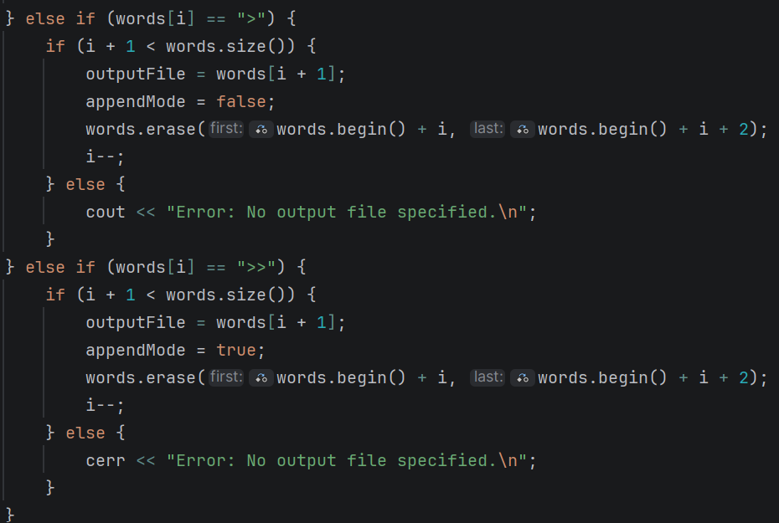
- >: Identifies the next token as the output destination (overwrite).
- >>: Identifies the next token as the output destination (append).
- Once identified, the symbols and filenames are erased from the words vector, so they aren't passed as arguments to the actual command.

3.4 Built-in Command Implementation
The shell manually handles several commands:
- cd:
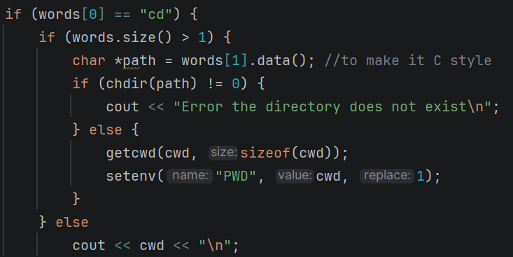
  - Accpets a directory name from the user.
  - Print an error if the directory does not exist.
  - Changes the PWD directory in the using the setenv().

- dir:
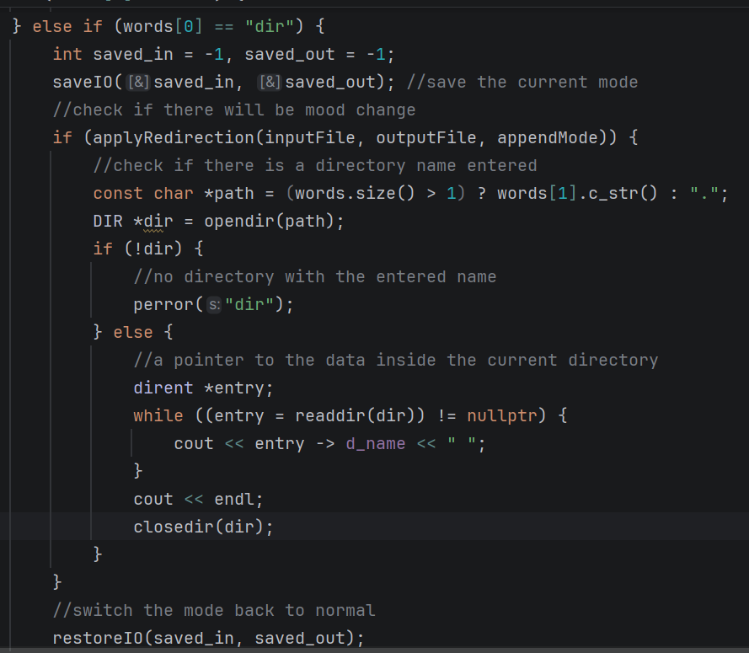
  - Performs a check if the user enters a directory name.
    - If no directory, then the shell opens the current directory.
    - If there is a directory, then the shell tries to open that directory.
  - After the directory is opened, a pointer to the directory content is initialized (dirent).
  - A loop starts to print the directory content.
  - The directory is then closed.

- environ:
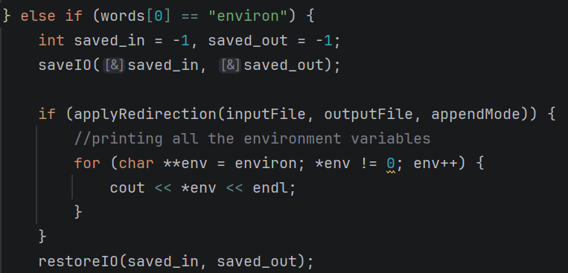
  - A loop is made on all the environment variables from the global pointer.
- set:
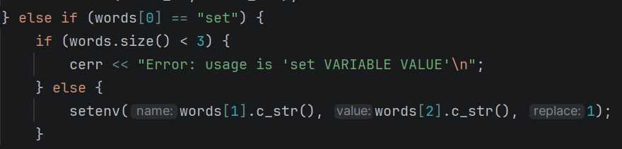
  - using the setenv(), it accepts a variable name and value.
  - The variable data is changed to the value.
  - An error message is shown if there is missing values.

- echo:
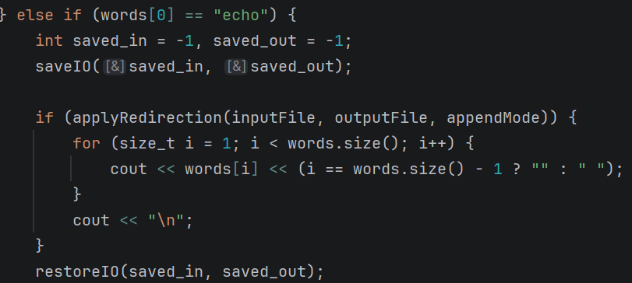
  - Print the entered string in the terminal
- help:
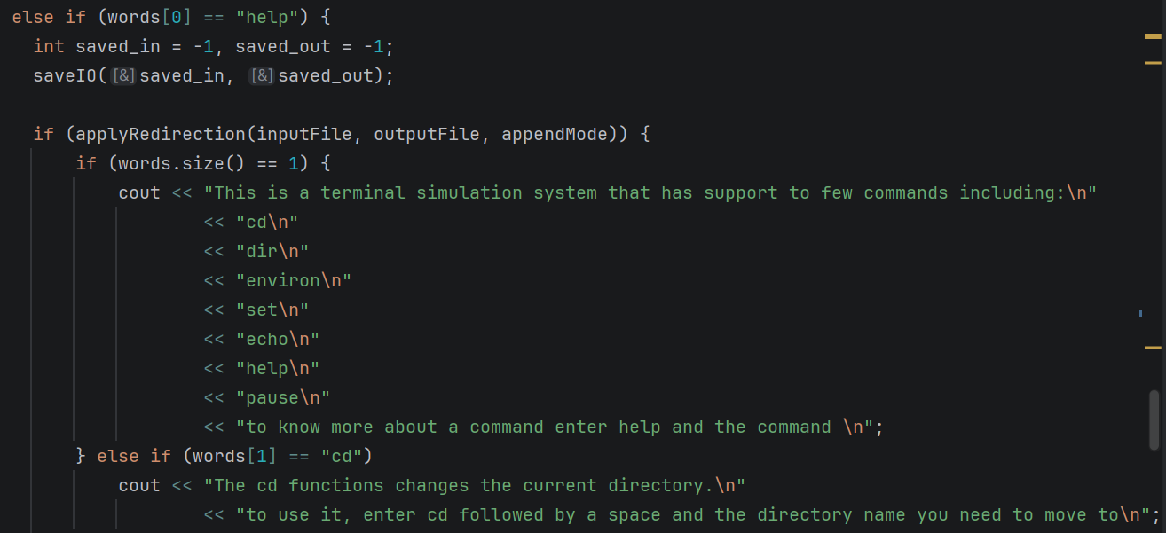
  - Displays a main message explaining the commands handled by the terminal
  - Can accept a string containing the command and the shell will print how to use the command

- pause:
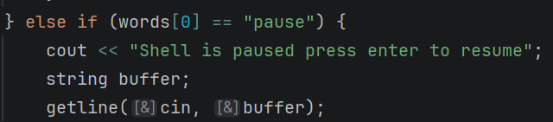
  - Uses getline() to freeze the shell until the user presses enter.
- quit:
  - Breaks the loop to terminate the program.
3.5 External Command Execution (Process Management)
If the command is not a built-in, the shell attempts to run it as an external program:
- fork (): Creates a child process.
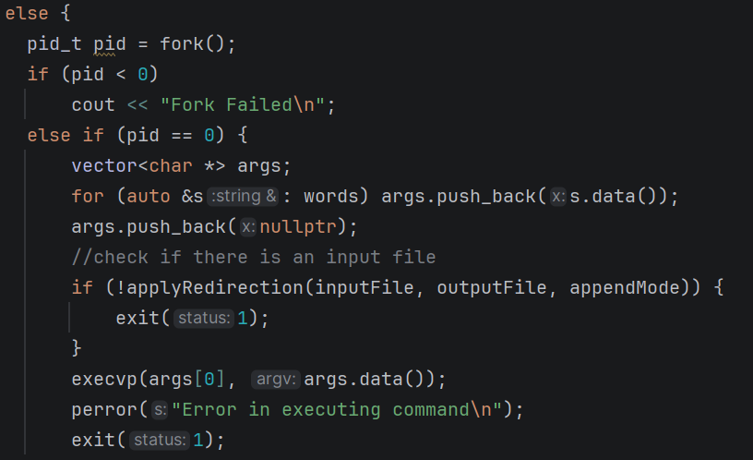
  - Child Process (PID == 0):

    - Converts the vector of strings into a C-style array of char*.
    - Applies any requested I/O redirection.
    - Calls execvp(), which searches the system's PATH for the executable and replaces the child process with it.

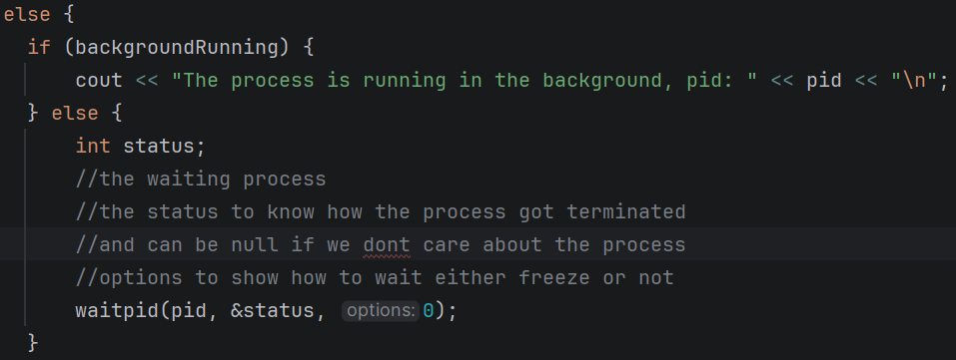
  - Parent Process (PID > 0):

    - If backgroundRunning is false, it calls waitpid() to wait for the child to finish.
    - If backgroundRunning is true, it prints the child's PID and immediately returns to the prompt, letting the child run asynchronously.

5. Github:
Repo link: https://github.com/youssef1316/OS_coursework1
Commit sha: d37090d

